# Suitable AI Courses Selector

CPCS-331 | Introduction to Software Project Management

Instructor: Dr.Nofe Alganmi

|  |  |  |
| --- | --- | --- |
| **Student Name** | **Student ID** | **Section** |
| Zinab Alsaggaf | 2006531 |  |
| Rawan Abdulsalaam | 1806606 | B1A |
| Reena Almahyawi | 2006114 |  |

Submit Date: 22-10-2022

Table of Contents

Suitable Courses Selector 1

Task Assignment 3

1. Tasks 3

2. Team Members’ Contribution for Each Task 3

Introduction 4

1. The Purpose Of The Chosen Expert System 4

2. The Users Of The System 4

3. The Expert(S) 4

4. The Resources That Will Be Used 4

Body 5

1. List Of Rules 5

13. The Technique Used To Acquire Knowledge From The System 7

14. The System's Flowchart 7

References 8

Appendix 9

1. Source code 9

2. Screenshots of your system 13

# Task Assignment

## Tasks

* Gathering Information
* Writing report
* Building knowledge base
* Writing code
* Drawing System flowchart
* Acquiring references

## Team Members’ Contribution for Each Task

|  |  |
| --- | --- |
| **Team Member** | **Contribution** |
| Zinab Alsaggaf |  |
| Reena Almahyawi | All Tasks |
| Rawan Abdulsalaam |  |

# Introduction

## The Purpose Of The Chosen Expert System

Our expert system is designed to help students choose the suitable AI learning courses for them. Rather than spend the students' time trying to find a course that fits their needs and is suitable for them, we decided to build a system that allows them to choose the courses based on a number of questions, and then the system will suggest the most appropriate courses for them.

## The Users Of The System

The users of the system are students of technology majors.

## The Expert(S)

Based on user’s answers to the questions, the system display list of appropriate AI courses.

## The Resources That Will Be Used

Official and high standard online Courses from various websites such as, Coursera, edX, and Udemy.

# 

# Body

## List Of Rules

1. If the user answer is “Paid and duration (1-3) months and Easy”

Then suitable courses are:

* [Machine Learning Specialization](https://www.coursera.org/specializations/machine-learning-introduction)
* [IBM AI Foundations for Business Specialization](https://www.coursera.org/specializations/ibm-ai-foundations-for-business)

1. If the user answer is “Paid and duration (1-3) months and Intermediate”

Then suitable courses are:

* [Tens AI for Medicine Specialization](https://www.coursera.org/specializations/ai-for-medicine)
* [Introduction to Machine Learning](https://www.coursera.org/learn/machine-learning-duke)

1. If the user answer is “Paid and duration (1-3) months and Hard”

Then suitable courses are:

* [The Economics of AI](https://www.coursera.org/learn/economics-of-ai)
* [Developing AI Applications on Azure](https://www.coursera.org/learn/developing-ai-applications-azure)

1. If the user answer is “Paid and duration (3-6) months and Easy”

Then suitable courses are:

* [IBM Applied AI Professional Certificate](https://www.coursera.org/professional-certificates/applied-artifical-intelligence-ibm-watson-ai)
* [AI Foundations for Everyone Specialization](https://www.coursera.org/specializations/ai-foundations-for-everyone)

1. If the user answer is “Paid and duration (3-6) months and Intermediate”

Then suitable courses are:

* [IBM AI Engineering Professional Certificate](https://www.coursera.org/professional-certificates/ai-engineer)
* [Deep Learning Specialization](https://www.coursera.org/specializations/deep-learning)

1. If the user answer is “Paid and duration (3-6) months and Hard”

Then suitable courses are:

* [The Economics of AI](https://www.coursera.org/learn/economics-of-ai)
* [IBM AI Enterprise Workflow Specialization](https://www.coursera.org/specializations/ibm-ai-workflow)

1. If the user answer is “free and duration (1-3) months and Easy”

Then suitable courses are:

* [CS50's Introduction to Artificial Intelligence with Python](https://pll.harvard.edu/course/cs50s-introduction-artificial-intelligence-python?delta=0)
* [Fundamentals of TinyML](https://pll.harvard.edu/course/fundamentals-tinyml?delta=0)
* [Python with AI](https://www.udemy.com/course/pythonwithai/)

1. If the user answer is “free and duration (1-3) months and Intermediate”

Then suitable courses are:

* [Amazing AI: Reverse Image Search](https://www.udemy.com/course/practical-deep-learning-image-search-engine/)
* [Intro to Artificial Intelligence](https://www.udacity.com/course/intro-to-artificial-intelligence--cs271)

1. If the user answer is “free and duration (1-3) months and Hard”

Then suitable courses are:

* [Understanding Artificial Intelligence through Algorithmic Information Theory](https://www.edx.org/course/artificial-intelligence-algorithmic-information-aiai?index=product_value_experiment_a&queryID=3466111859de18877a669c291f814f03&position=3)
* [Quantum Machine Learning](https://www.edx.org/course/quantum-machine-learning?index=product_value_experiment_a&queryID=9984dca73ba8dac14cea35208e3e490c&position=11)

1. If the user answer is “free and duration (3-6) months and Easy”

Then suitable courses are:

* [Data and AI Fundamentals](https://www.edx.org/course/data-and-ai-fundamentals?index=product_value_experiment_a&queryID=545a46ba71877c1aa3c673cd99b3ade6&position=6)
* [Artificial Intelligence Markup Language (AIML)](https://www.udemy.com/course/artificial-intelligence-markup-language/)

1. If the user answer is “free and duration (3-6) months and Intermediate”

Then suitable courses are:

* [Machine Learning](https://www.edx.org/course/machine-learning-4?index=product_value_experiment_a&queryID=f16c7f1efb41d144d9ba13d4f43fdfd7&position=3)
* [Leading Digital and Data Decision Making](https://www.edx.org/course/leading-digital-and-data-decision-making-2?index=product_value_experiment_a&queryID=f16c7f1efb41d144d9ba13d4f43fdfd7&position=8)

1. If the user answer is “free and duration (3-6) months and Hard”

Then suitable courses are:

* [AI for Leaders](https://www.mygreatlearning.com/academy/learn-for-free/courses/ai-for-leaders1)
* [Learn to Build an In-App Voice AI Assistant](https://www.udemy.com/course/alan-ai-course/)

## The Technique Used To Acquire Knowledge From The System

The techniques we used in our project are user input, functions, knowledge engine class, fact class and Experta python library by using python as a programming language.

## The System's Flowchart

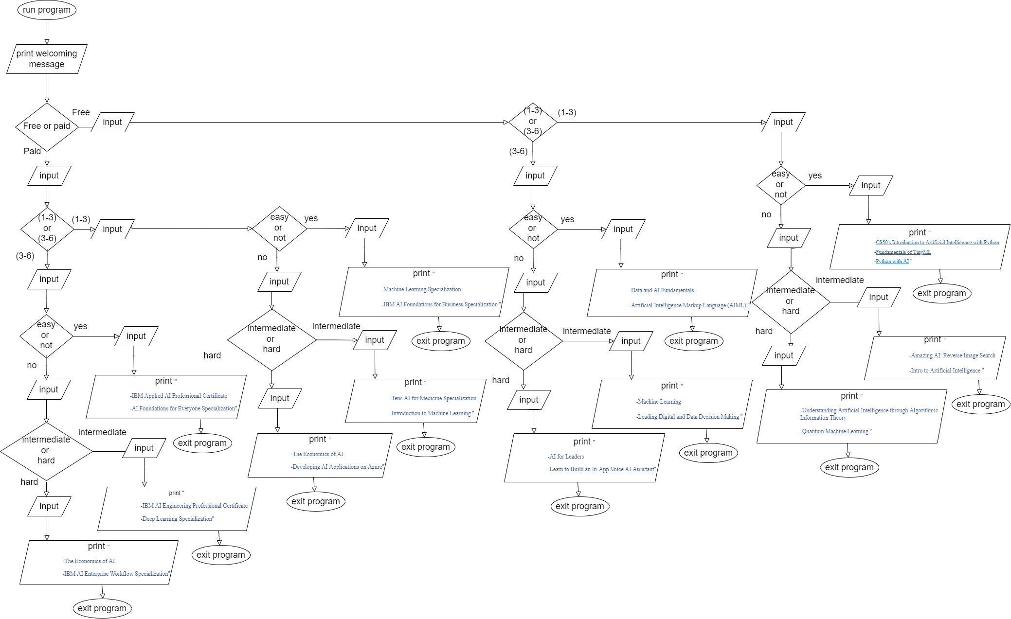

# References

1. “edX Courses | Online Courses on edX.org.” *edX*, www.edx.org/search?utm_campaign=gs-b2c-sitelinks-search-courses&utm_source=google&utm_medium=cpc&utm_term=edx. Accessed 19 Oct. 2022.
2. “Online Courses - Learn Anything, on Your Schedule | Udemy.” *Udemy*, www.udemy.com/?utm_source=aff-campaign&utm_medium=udemyads&LSNPUBID=0EOJOrTo2D4&ranMID=47901&ranEAID=0EOJOrTo2D4&ranSiteID=0EOJOrTo2D4-1axOqzGudISVbW4aYUEAxA. Accessed 19 Oct. 2022.
3. “Coursera - Google Search.” *Coursera - Google Search*, www.google.com/search?gs_ssp=eJzj4tLP1TfIssxOSqpSYDRgdGDw4kjOLy0qTi1KBABhDwek&q=coursera&rlz=1C5CHFA_enSA1024SA1025&oq=cour&aqs=chrome.1.35i39i355j46i39i199i465j69i57j69i60l3j69i65j69i60.1583j0j4&sourceid=chrome&ie=UTF-8. Accessed 19 Oct. 2022.

# Appendix

## Source code

! pip install experta

! pip install simple_colors

from experta import *

from simple_colors import *

class Course(Fact):

pass

class SuitableCourseKBA(KnowledgeEngine):

# rule 1

@Rule(AND(Course(freeOrPaid = "paid"), Course(duration = "1-3"), Course(level = "easy")))

def select_course1(self):

print("• Machine Learning Specialization")

print(" https://www.coursera.org/specializations/machine-learning-introduction")

print("")

print("• IBM AI Foundations for Business Specialization")

print(" https://www.coursera.org/specializations/ibm-ai-foundations-for-business")

# rule 2

@Rule(AND(Course(freeOrPaid = "paid"), Course(duration = "1-3"), Course(level = "intermediate")))

def select_course2(self):

print("• Tens AI for Medicine Specialization")

print(" https://www.coursera.org/specializations/ai-for-medicine")

print("")

print("• Introduction to Machine Learning")

print(" https://www.coursera.org/learn/machine-learning-duke")

# rule 3

@Rule(AND(Course(freeOrPaid = "paid"), Course(duration = "1-3"), Course(level = "hard")))

def select_course3(self):

print("• The Economics of AI")

print(" https://www.coursera.org/learn/economics-of-ai")

print("")

print("• Developing AI Applications on Azure")

print(" https://www.coursera.org/learn/developing-ai-applications-azure")

# rule 4

@Rule(AND(Course(freeOrPaid = "paid"), Course(duration = "3-6"), Course(level = "easy")))

def select_course4(self):

print("• IBM Applied AI Professional Certificate")

print(" https://www.coursera.org/professional-certificates/applied-artifical-intelligence-ibm-watson-ai")

print("")

print("• AI Foundations for Everyone Specialization")

print(" https://www.coursera.org/specializations/ai-foundations-for-everyone")

# rule 5

@Rule(AND(Course(freeOrPaid = "paid"), Course(duration = "3-6"), Course(level = "intermediate")))

def select_course5(self):

print("• IBM AI Engineering Professional Certificate")

print(" https://www.coursera.org/professional-certificates/ai-engineer")

print("")

print("• Deep Learning Specialization")

print(" https://www.coursera.org/specializations/deep-learning")

# rule 6

@Rule(AND(Course(freeOrPaid = "paid"), Course(duration = "3-6"), Course(level = "hard")))

def select_course6(self):

print("• The Economics of AI")

print(" https://www.coursera.org/learn/economics-of-ai")

print("")

print("• IBM AI Enterprise Workflow Specialization")

print(" https://www.coursera.org/specializations/ibm-ai-workflow")

# rule 7

@Rule(AND(Course(freeOrPaid = "free"), Course(duration = "1-3"), Course(level = "easy")))

def select_course7(self):

print("• CS50's Introduction to Artificial Intelligence with Python")

print(" https://pll.harvard.edu/course/cs50s-introduction-artificial-intelligence-python?delta=0")

print("")

print("• Fundamentals of TinyML")

print(" https://pll.harvard.edu/course/fundamentals-tinyml?delta=0")

print("")

print("• Python with AI")

print(" https://www.udemy.com/course/pythonwithai/")

# rule 8

@Rule(AND(Course(freeOrPaid = "free"), Course(duration = "1-3"), Course(level = "intermediate")))

def select_course8(self):

print("• Amazing AI: Reverse Image Search")

print(" https://www.udemy.com/course/practical-deep-learning-image-search-engine/")

print("")

print("• Intro to Artificial Intelligence")

print(" https://www.udacity.com/course/intro-to-artificial-intelligence--cs271")

# rule 9

@Rule(AND(Course(freeOrPaid = "free"), Course(duration = "1-3"), Course(level = "hard")))

def select_course9(self):

print("• Understanding Artificial Intelligence through Algorithmic Information Theory")

print(" https://www.edx.org/course/artificial-intelligence-algorithmic-information-aiai?index=product_value_experiment_a&queryID=3466111859de18877a669c291f814f03&position=3")

print("")

print("• Quantum Machine Learning")

print(" https://www.edx.org/course/quantum-machine-learning?index=product_value_experiment_a&queryID=9984dca73ba8dac14cea35208e3e490c&position=11")

# rule 10

@Rule(AND(Course(freeOrPaid = "free"), Course(duration = "3-6"), Course(level = "easy")))

def select_course10(self):

print("• Data and AI Fundamentals")

print(" https://www.edx.org/course/data-and-ai-fundamentals?index=product_value_experiment_a&queryID=545a46ba71877c1aa3c673cd99b3ade6&position=6")

print("")

print("• Artificial Intelligence Markup Language (AIML)")

print(" https://www.udemy.com/course/artificial-intelligence-markup-language/")

# rule 11

@Rule(AND(Course(freeOrPaid = "free"), Course(duration = "3-6"), Course(level = "intermediate")))

def select_course11(self):

print("•Machine Learning")

print(" https://www.edx.org/course/machine-learning-4?index=product_value_experiment_a&queryID=f16c7f1efb41d144d9ba13d4f43fdfd7&position=3")

print("")

print("•Leading Digital and Data Decision Making")

print(" https://www.edx.org/course/leading-digital-and-data-decision-making-2?index=product_value_experiment_a&queryID=f16c7f1efb41d144d9ba13d4f43fdfd7&position=8")

# rule 12

@Rule(AND(Course(freeOrPaid = "free"), Course(duration = "3-6"), Course(level = "hard")))

def select_course12(self):

print("• AI for Leaders")

print(" https://www.mygreatlearning.com/academy/learn-for-free/courses/ai-for-leaders1")

print("")

print("• Learn to Build an In-App Voice AI Assistant")

print(" https://www.udemy.com/course/alan-ai-course/")

engine = SuitableCourseKBA()

engine.reset()

print(cyan("Hello!\nFor helping you in finding the suiatble AI course please answer the following questions:\n",'dim'))

freeOrPaid_now = input("Free or Paid course? ").lower()

duration_now = input("Course Duration (1-3) or (3-6) Months? ").lower()

level_now = input("Course level (Easy) or (Intermediate) or (Hard)? ").lower()

engine.declare(Course(freeOrPaid = freeOrPaid_now, duration = duration_now, level = level_now))

print(blue('\nSuitable Courses for you are: \n','bold'))

engine.run()

print(cyan("\n\nThank you for using our expert system",'blink'))

## Screenshots of our system

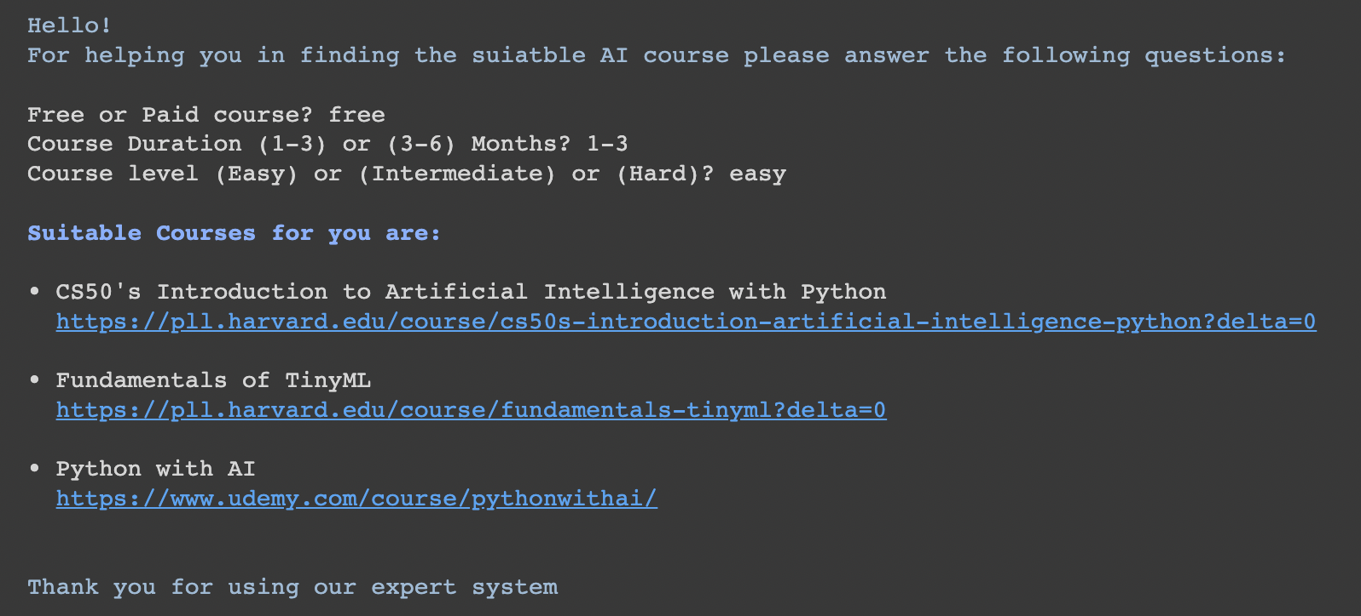

Figure 1 Sample Output

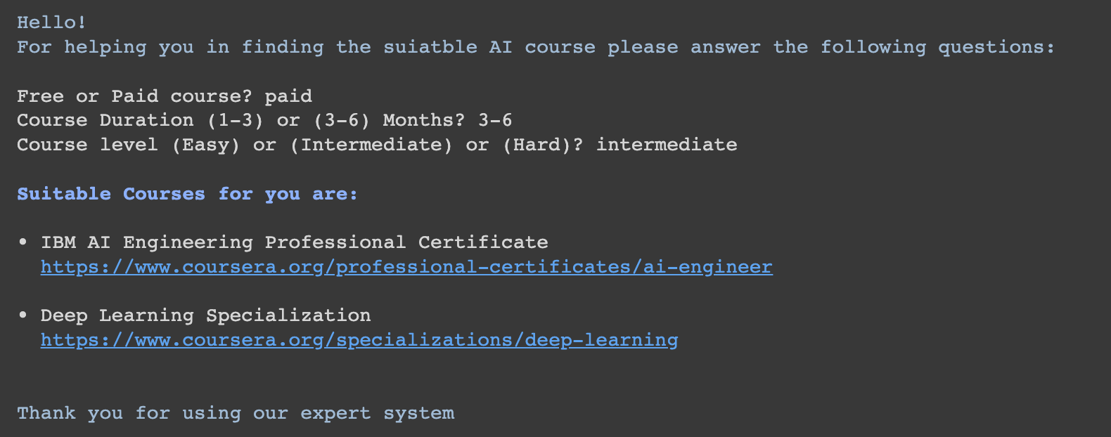

Figure 2 Sample Output

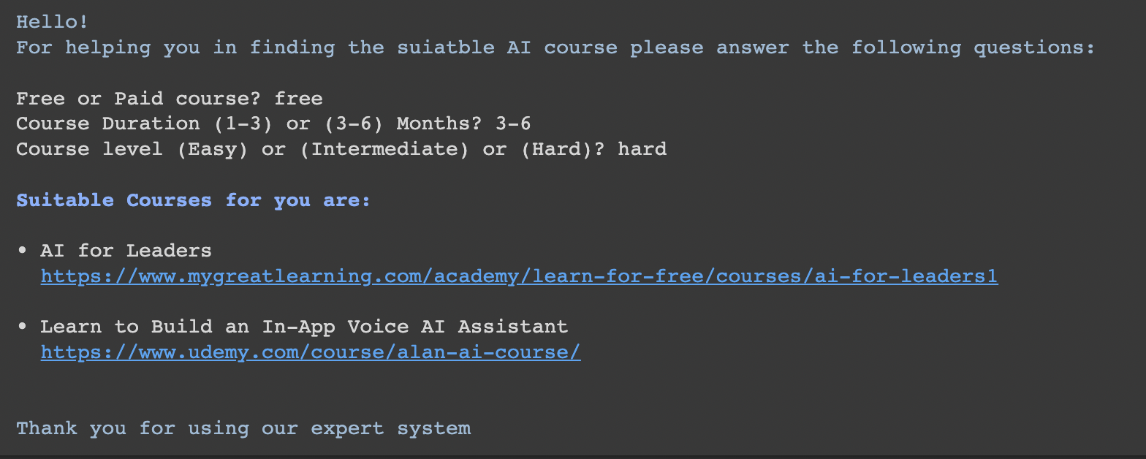

Figure 3 Sample Output

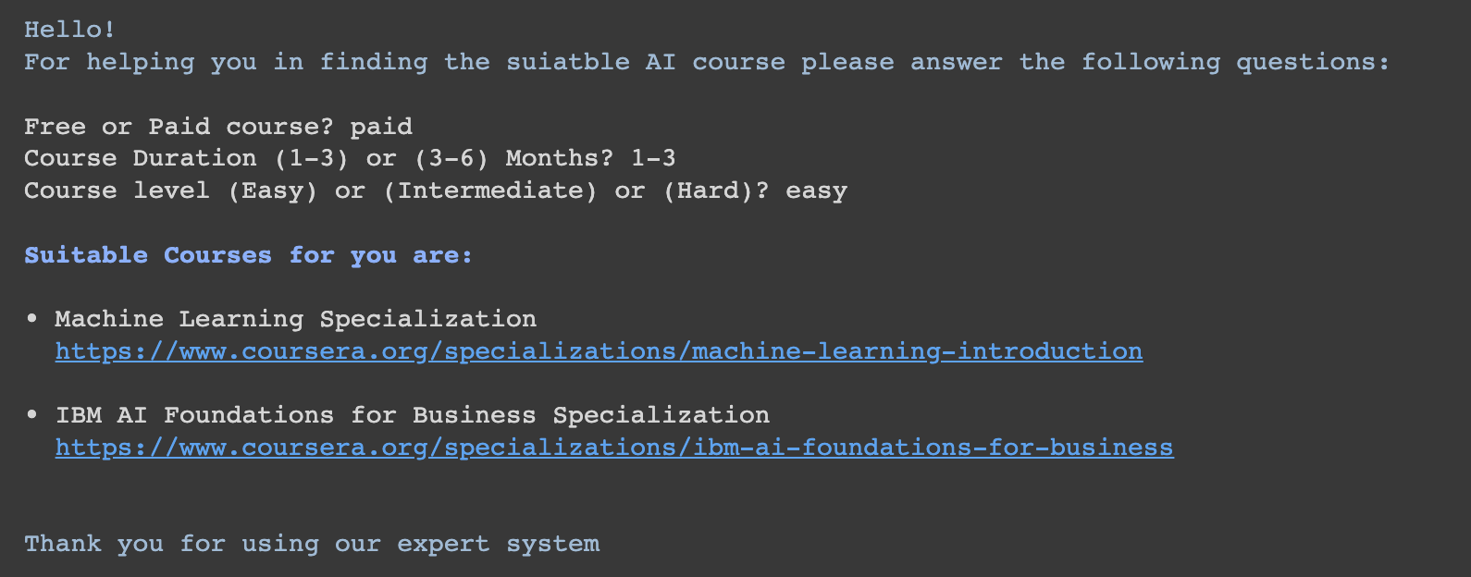

Figure 4 Sample output